Risk and Return

Return, Risk and the Security Market Line

Expected Return and Variance

- "What is the chance of an investment's price or return going up and down?"

- Investment risk

Expected Return: Return on a risky asset expected in the future

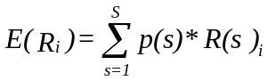

where p(s) denotes the probability of state s, R(s) denotes the return in state s.

Variance: Measures the dispersion of an asset's returns around its expected return.

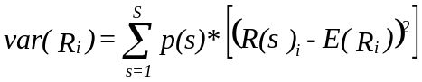

Standard deviation: The square root of the variance.

Expected Return and Variance
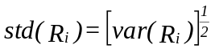

Example: What is the expected return to the amusement park and ski resort stock?

State of weather | Probability | Return on amusement park stock | Return on ski resort stock
Very Cold | 0.1 | -15% | 35%
Cold | 0.3 | -5% | 15%
Average | 0.4 | 10% | 5%
Hot | 0.2 | 30% | -5%

Mean or expected value:

E(X) = prob₁X₁+ prob₂X₂+ ... + prob_{n}X_{n} =

Where i = one possible outcome
prob_{I} = the probability of outcome i
X_{i} = the return if outcome i happens
n = the total number of possible outcomes

Example: Let A denote the amusement park and S denote the ski resort

E(R_{A}) = 0.1 (-0.15) + 0.3 (-0.05) + 0.4 (0.10) + 0.2 (0.30) = 7.00%

E(R_{S}) = 0.1 (-0.35) + 0.3 (0.15) + 0.4 (0.05) + 0.2 (-0.05) = 9.00%

Variance and standard deviation:

Variance of X = ∑^{n}_{i=1} (prob_{i}[x_{i}-(E(x)]²)

Standard deviation=(var)^{1/2}

For the amusement park and the ski resort we have:

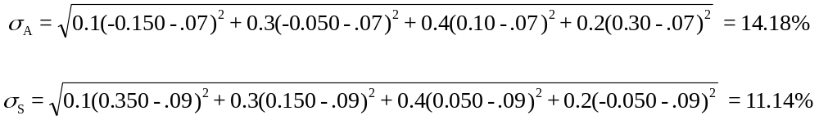

The standard deviation is a measure of stand-alone risk.

Risk: Systematic and Unsystematic

Stand-alone risk is measured by dispersion of returns about the mean and is relevant only for assets held in isolation. It consists of:

- Diversifiable (company-specific, unique, or unsystematic)

- Non-diversifiable (market or systematic)

Risk | Type of Risk
Risk of inflation
Risk of a CEO resigning
Risk of a takeover
Risk of a labor strike

Coefficient of Variation - Standardized measure of dispersion about the expected value. Shows risk per unit of return.
Covariance and correlation

It is important in portfolio theory to know how two stocks move together, or how a stock moves with the market. There are two measures of this, covariance and correlation.

We can calculate the covariance as follows:

Covariance of X and Y = 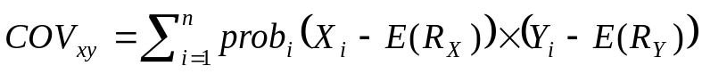

For the amusement park and the ski resort we have:

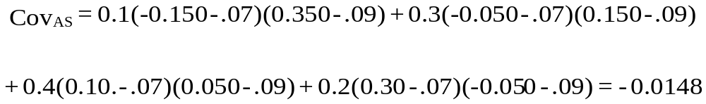

The negative covariance tells you that the stocks tend to move in opposite directions.

The covariance gives you a sense of both the magnitude and the direction of how stocks move together. Sometimes it is useful to have a measure of how stock move together, which is independent of the size of the “swings”, and just gives an idea of how tightly two stock “track” each other.

We can calculate the correlation coefficient as follows.

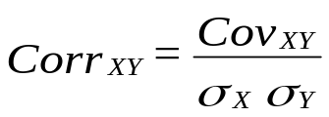

The correlation coefficient is always between -1.0 and 1.0:

-1.0 ≤ Corr_{XY} ≤ 1.0

For the amusement park and the ski resort we find the correlation is:

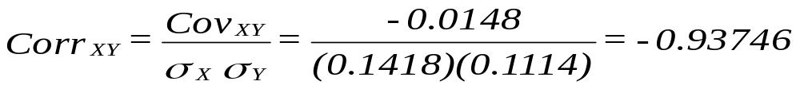

Portfolios

Portfolio: A group of securities, such as stocks and bonds, held by an investor.

Portfolio weights: Percentages of the portfolio's total value invested in each security.

Example: Your portfolio consists of IBM stock and GM stock. You have $2,500 invested in IBM and $7,500 invested in GM. What are the portfolio weights?

Expected Return on a portfolio: Weighted average of the expected returns on the individual securities in the portfolio. Let w_{n} denote a security's portfolio weight, then

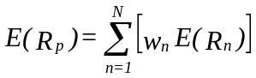

Portfolio Variance: Unlike the expected return, the variance of a portfolio is not a simple weighted average of the individual security variances,

We can use this formula or we can compute the returns for the portfolio and then computes its expected return and variance.
Example: Expected Return and Variance of Portfolio Returns

In our earlier example, there are two stocks, the Amusement Park and the Ski Resort.

We know the following:

E(R_{A}) = 7% E(R_{S}) = 9%
σ_{A}=14.18% σ_{S} = 11.14%

Say we have $100 and invest $50 into A and $50 into S. What can we expect to make on our portfolio?

We have a weight of 50% in A and 50% in S (the weights don't have to be 50-50)

E(R_{p}) = 0.5 ( 7%) + 0.5 (9%) = 8%

Generally, expected portfolio return = E(R_{p}) =∑w_{i} × E(r_{i})

Expected portfolio risk

To measure the risk of the portfolio, we have to account for how the stocks move together. For two stocks X and Y the relation is:

Where: W_{X} = % of wealth in asset X
W_{Y} = % of wealth in asset Y
W_{X} + W_{Y} = 1

And 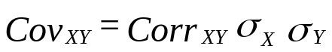

As the covariance gets more negative, the portfolio can be made less risky.

Risk - Return tradeoffs.

In the Ski Resort example, say we divide our money 50-50 between the two stocks.

The correlation between the two stocks is -0.9375, σ_{A} = 14.18%, σ_{S} = 11.14%,
W_{A} = 0.5, W_{S} = 0.5.

So:
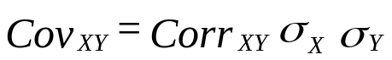= -0.9374 × 0.1418 × 0.1114 = -0.0148

And:
Our answer tells us something very important - the risk of the portfolio of the two stocks is less than the risk of either one by itself.

In general, the lower the correlation between the stocks the lower the risk of the portfolios of both stocks.

As a reminder, so far we have found the following:

E(R_{A}) = 7% E(R_{S}) = 9%
σ_{A} = 14.18% σ_{S} = 11.14% Corr_{AS} = -0.9375

And we have the portfolio expected returns and portfolio standard deviations:

W_{A} (%) | W_{B} (%) | SD(R_{P}) (%) | E(R_{P}) (%)
100.00 | 0.00 | 14.18 | 7.00
90.00 | 10.00 | 11.72 | 7.20
80.00 | 20.00 | 9.29 | 7.40
70.00 | 30.00 | 6.89 | 7.60
60.00 | 40.00 | 4.60 | 7.80
50.00 | 50.00 | 2.69 | 8.00
40.00 | 60.00 | 2.40 | 8.20
30.00 | 70.00 | 4.09 | 8.40
20.00 | 80.00 | 6.33 | 8.60
10.00 | 90.00 | 8.71 | 8.80
0.00 | 100.00 | 11.14 | 9.00

We can plot these risk-return combinations in a graph:

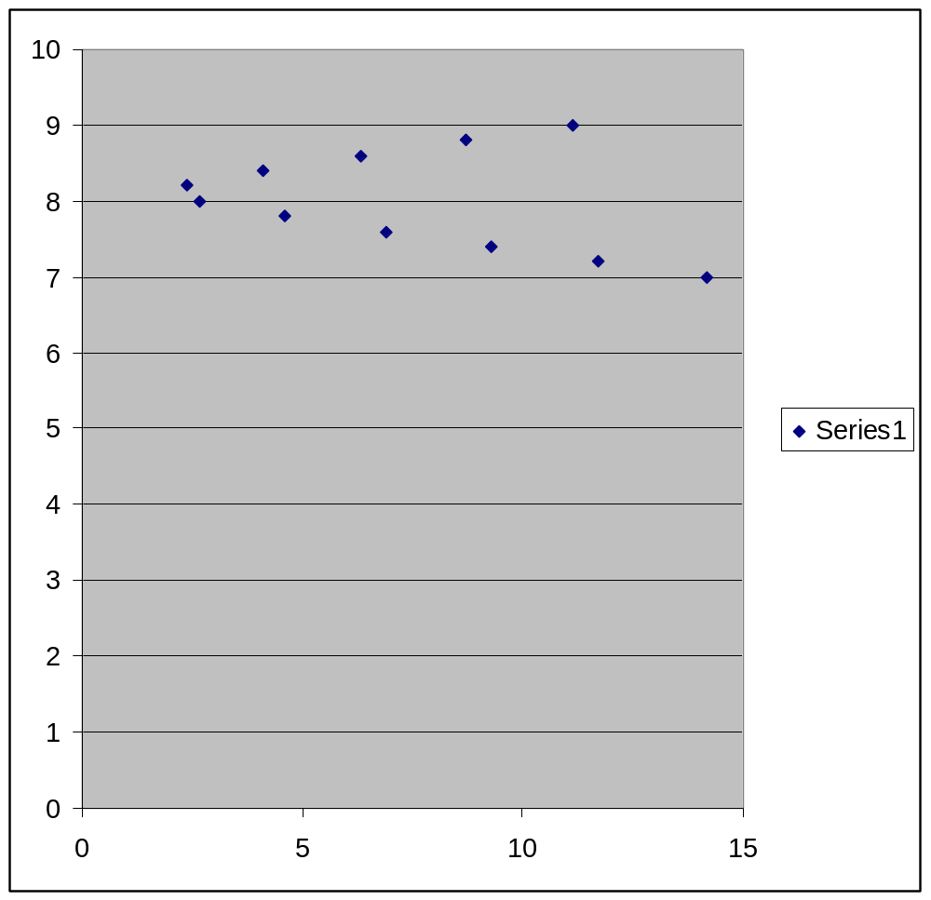

Risk Free Asset

Say that we have 2 assets, X and Y, but Y is risk free, i.e., σ_{Y} = 0.

Then:
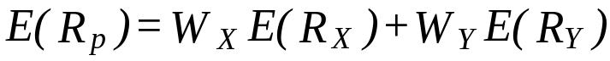

or

Let's say that there is a risky asset (X) and a risk free asset (F)

Risky Asset: E(R_{X}) = 0.16, σ_{X} = 8%
Risk Free Asset: E(R_{F}) = 0.06, σ_{F} = 0%

You have $100, you put $50 in X and $50 in F (i.e., lending $50 at the risk free rate). The weights are:

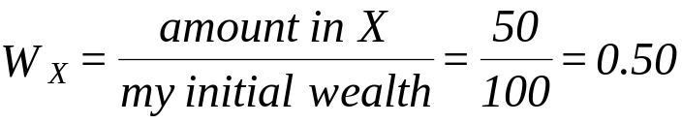
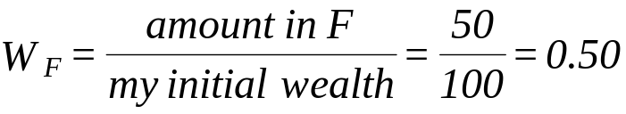

E(R_{p}) = W_{X}E(R_{X}) + W_{Y}E(R_{Y}) = 0.5 (16) + 0.5 (6) = 11%

SD(R_{P}) = W_{X}σ_{X} = 0.5 (8) = 4%

You have $100 and you borrow $50 from F and put $150 in X

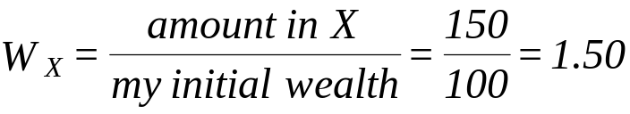
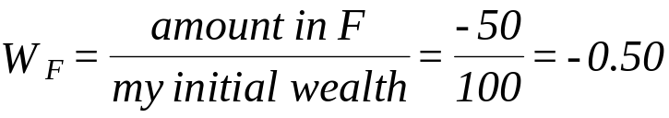

Note: the weights always add up to 1.0.

E(R_{p})=W_{X}E(R_{X}) + W_{Y}E(R_{Y})=1.5 (16%) + (-0.5) (6%)=21%

SD(R_{P}) = W_{X}σ_{X} = 1.5 (8) = 12%

If we compute the expected return and standard deviation for a variety of weights, we can build a table as we did before:

W_{F} (%) | W_{X} (%) | SD(R_{P}) (%) | E(R_{P}) (%)
100.00 | 0.00 | 0.00 | 6.00
80.00 | 20.00 | 1.60 | 8.00
50.00 | 50.00 | 4.00 | 11.00
20.00 | 80.00 | 6.40 | 14.00
0.00 | 100.00 | 8.00 | 16.00
-50.00 | 150.00 | 12.00 | 21.00

And plot the expected portfolio return vs. the standard deviation:

In our return - standard deviation graph, when we combine a risk free asset with a risky asset the risk - return tradeoff is a straight line.

Diversification

Principle of Diversification: Spreading an investment across a number of assets will eliminate some, but not all, of the risk. Diversification is not putting all your eggs in one basket.

- A typical NYSE stock has a standard deviation of annual returns of 49.24%, while the typical portfolio of 100 or more stocks has a standard deviation just under 20%.

- Diversifiable risk: The variability present in a typical single security that is not present in a portfolio of securities.

- Nondiversifiable risk: The level of variance that is present in a collection or portfolio of assets.

Average annual
standard deviation (%)
Number of stocks
in portfolio
Diversifiable (firm specific) risk
Nondiversifiable
(Market) risk
49.2
23.9
19.2
1
10
20
30
40
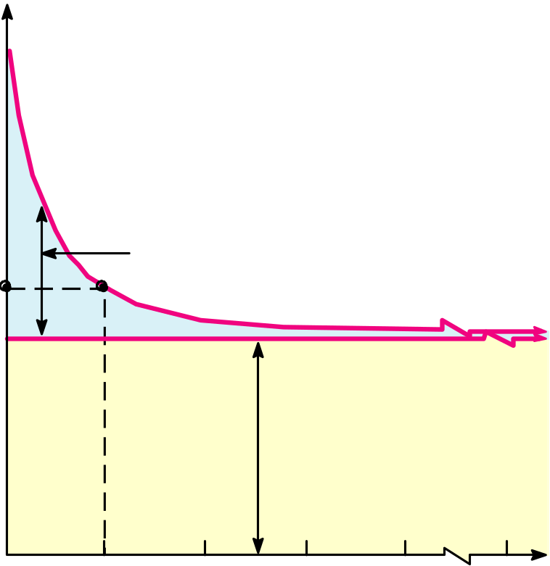
Portfolio Diversification (Figure 13.1)
1000

Systematic Risk and Beta

The Systematic Risk Principle

- The reward for bearing risk depends only upon systematic risk of investment since unsystematic risk can be diversified away.

- This implies that the expected return on any asset depends only on that asset's systematic risk

Measuring Systematic Risk

- Beta, β, is a measure of how much systematic risk an asset has relative to an average risky asset. An example of an average risky asset is the market portfolio. An example of the market portfolio is the S&P index.

- Portfolio Betas: While portfolio variance is not equal to a simple weighed sum of individual security variances, portfolio betas are equal to the weighed sum of individual security betas.
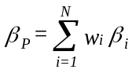

- You have $6,000 invested in IBM, $4,000 in GM. The beta of IBM and GM is 0.75 and 1.2 respectively. What is the beta of the portfolio?
Calculating Betas

Run a regression line of past returns on Stock i versus returns on the market.

The regression line is called the characteristic line.

The slope coefficient of the characteristic line is defined as the beta coefficient.

- If beta = 1.0, stock is average risk.

- If beta > 1.0, stock is riskier than average.

- If beta < 1.0, stock is less risky than average.

- Most stocks have betas in the range of 0.5 to 1.5.

Beta and Risk Premium

- A risk free asset has a beta of zero

- When a risky asset is combined with a risk free asset, the resulting portfolio expected return is a weighted sum of their expected returns and the portfolio beta is the weighted sum of their betas.

- Considers various portfolios comprised of an investment in stock A with a beta (β) of 1.2 and expected return of 18%, and a Treasury bill with a 7% return. Compute the expected return and beta for different portfolios of stock A and a Treasury bill.

w_{A} | w_{rf} | E(R_{p}) | β_{p}
0.0 | 1.00
0.25 | 0.75
0.50 | 0.50
0.75 | 0.25
1.00 | 0.00

- We can vary the amount invested in each type of asset and get an idea of the relation between portfolio expected return and portfolio beta.

- Reward-to-Risk-Ratio: 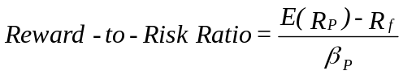

What if 2 assets (stocks, or risk free asset) have different
Reward-to-Risk-Ratios?

Fundamental Results:

- Portfolio expected returns and beta combinations lie on a straight line with slope (=rise/run) equal to:
- The reward-to-risk ratio is the expected return per "unit" of systematic risk, or, in other words, the ratio of the risk premium and the amount of systematic risk.

- Since systematic risk is all that matters in determining expected return, the reward-to-risk ratio must be the same for all assets and portfolios. If not, investors would only buy the assets (portfolios) that offer a higher reward-to-risk ratio.

- Because the reward-to-risk ratio is the same for all assets, it must hold for the risk free asset as well as for the market portfolio.

- Result:

Security Market Line

Security Market Line: The security market line is the line which gives the expected return-systematic risk (beta) combinations of assets in a well functioning, active financial market.

- In an active, competitive market in which only systematic risk affects expected return, the reward-to-risk ratio must be the same for all assets in the market.

- Market Portfolio: Portfolio of all the assets in the market. This portfolio by definition has "average" systematic risk. That is, its beta is one. Since all assets must lie on the security market line, so must the market portfolio. Let E(R_{M}) denote the expected return on the market portfolio.

- Expected Market risk premium: E(R_{M}) - R_{f}

Capital Asset Pricing Model (CAPM)

Since all assets have the same reward-to-risk ratio as well as the market portfolio we can prove:

E(R_{i}) = R_{f} + [E(R_{M}) - R_{f}]β_{i}

The expected return on an asset depends on:

! time value of money, as measure by

! reward per unit of systematic risk, as measured by

! systematic risk, as measured by

Example of using CAPM: Suppose an asset has 1.5 times the systematic risk as the market portfolio (average asset). If the risk-free rate as measured by the Treasury bill rate is 5% and the expected risk premium on the market portfolio is 8%, what is the stock's expected return according to the CAPM?

CAPM and Capital Budgeting: To determine the appropriate discount rate for use in evaluating an investment's value, we need a discount rate that reflects risk. CAPM measures risk.

- Determine an investment's beta

- Find the expected return using CAPM for that beta and use this interest rate as the appropriate discount rate.
Summary of Risk and Return

- Total risk - the variance (or the standard deviation) of an asset’s return.

- Total return - the expected return + the unexpected return.

- Systematic and unsystematic risks

- Systematic risks are unanticipated events that affect almost all assets to some degree.

- Unsystematic risks are unanticipated events that affect single assets or small groups of assets.

- The effect of diversification - the elimination of unsystematic risk via the combination of assets into a portfolio.

- The systematic risk principle and beta - the reward for bearing risk depends only on its level of systematic risk.

- The reward-to-risk ratio - the ratio of an asset’s risk premium to its beta.

- The capital asset pricing model - E(R_{i}) = R_{f} + [E(R_{M}) - R_{f}] β_{i}

